Week 3 – Database Related Topics

RDBMS

JDBC

AWS – (RDS)

(MySQL/ Postgres)

(MySQL WorkBench/ PgAdmin)

Dbeaver (Additional Tool)

AWS – **A**mazon **W**eb **S**ervice (Cloud Service provided by Amazon)

<https://www.aws.amazon.com>

Everyone pls create a free-tier account in AWS (A valid debit/credit card is needed for sign-up)

1. A Email Address (Which is not previously used with AWS free-tier account)
2. Mobile Number
3. Debit/Credit card is needed

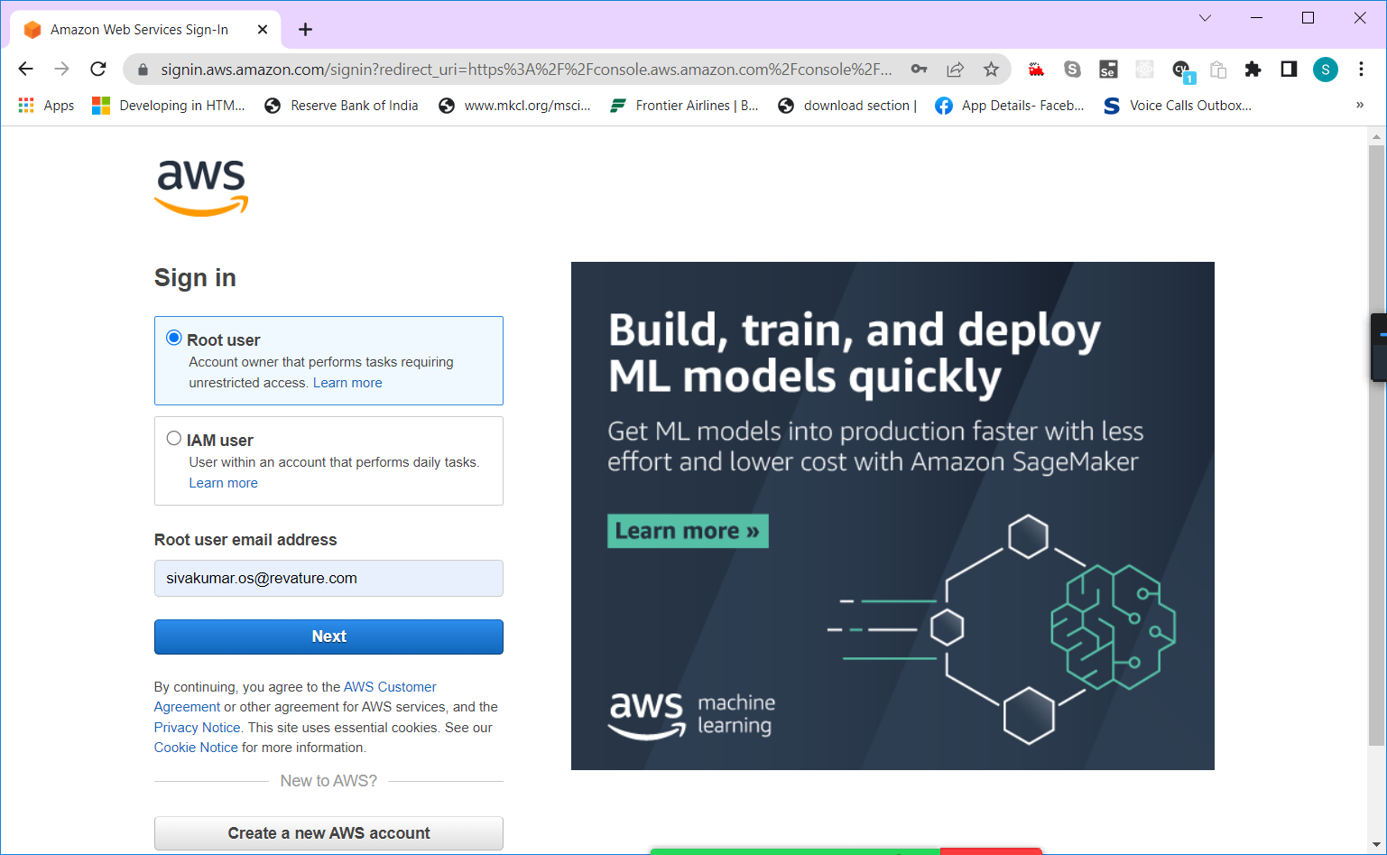

[https://aws.amazon.com/free/?all-free-tier.sort-by=item.additionalFields.SortRank&all-free-tier.sort-order=asc&awsf.Free%20Tier%20Types=*all&awsf.Free%20Tier%20Categories=*all](https://aws.amazon.com/free/?all-free-tier.sort-by=item.additionalFields.SortRank&all-free-tier.sort-order=asc&awsf.Free%20Tier%20Types=*all&awsf.Free%20Tier%20Categories=*all)

AWS – cloud Service from Amazon.

|  |  |  |
| --- | --- | --- |
| **Sl No** | **Company Name** | **Cloud Service Name** |
| 1 | Amazon | AWS (Amazon Web Service) |
| 2 | Microsoft | Azure |
| 3 | Google | GCP (Google Cloud Platform) |
| 4 | Redhat | OSP (OpenShift Platform) |

Web Service – A service offered via Web (Using Internet) [ Interaction between two electronic devices]

Cloud Service???

Planning to buy a desktop/laptop!!!!!

1. We will check the configurations, price and other details
2. Processor (i5,i7,i9) AMD, Apple Chip
3. RAM Capacity (8/16/32 GB RAM)
4. HDD (256GB/512GB/1TB) – SSD
5. Ports availability, size, speed, performance

Applications will be deployed in Servers ( servers – also computers with higher processing power, memory power, networking power etc.,)

Computing Service – Kind of Hardware only

Memory/Storage Service –

Networking Services –

Cloud service – It’s similar to the following Example.

Instead of Buying a House (Which huge initial investment), renting/ leasing a house.

Types of Clouds (With Respect to the Accessibility)

1. Public Cloud (shared resources – renting a house in apartment) – Low cost
2. Private Cloud (dedicated resources – spot instance – renting a villa/ individual house) - Costly
3. Hybrid Cloud (mixed of both private & public) comparatively lower than private and higher than public

Types of Cloud (Based on Service)

1. IaaS (Infrastructure as a Service) – Only Hardware No software
2. PaaS (Platform as a Service) – Hardware with OS & Other necessary software [EC2, EKS, ECS]
3. SaaS (Software as a Service) – Hardware with OS, Other software and Deployed code – Gmail, Google Drive, FaceBook, Office-365, MS-Office 2020, OneDrive

AWS Management Console

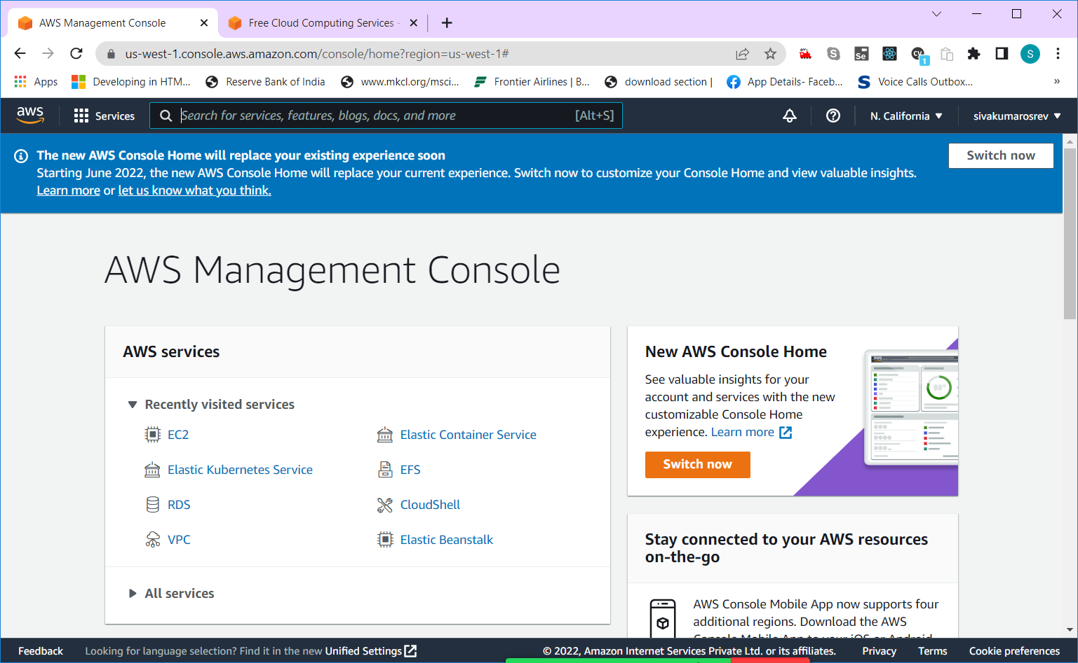

Latest Console Home

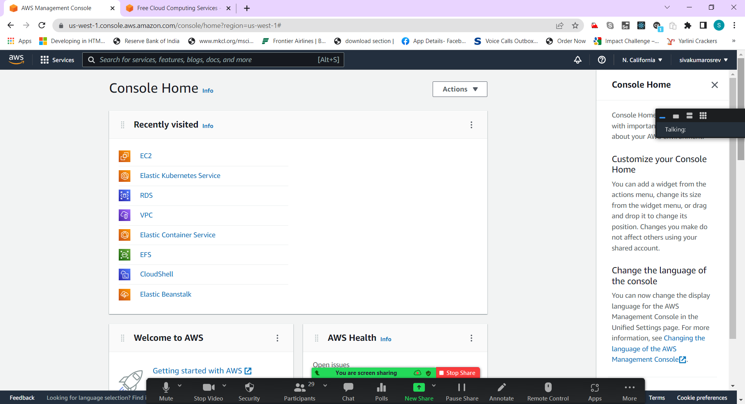

Compute Service – For Creating Virtual computers

Storage – Online Storage Service (Highly scalable)

AI, ML, AR & VR, Satellite, IoT, Blockchain, Developer Tools,

AI – Artificial Intelligence

ML – Machine Learning

AR – VR – Augmented / Virtual Reality

IoT – Internet of Technologies

AMI – Amazon Machine Image

RDS – Relational Database Service

IAM – ID & Access Management (Security Service)

IGW – Internet Gate Way

SG – Security Group

AWS is used for

1. Deploying application in Cloud
2. Creating a Virtual Machine/Server in Cloud
3. Storing Data or Files in Cloud
4. Developing Application on Cloud
5. Securing your application & Data in Cloud

Amazon AWS provides Services in Various Category

* Cloud Computing (Virtual Machines/ Virtual Servers)
* Cloud Storage (SSD based/ Magnetic Based scalable Storage on cloud)
* Database Services (Storage, Backup & Restore, DR [Disaster Recovery] – SQL & No SQL based
* Networking Services (IGW, SG, Subnet, IAM) – Role based access,
* Data Analytics Services & Data Migration Service
* Business Application Development ( AI, ML, IoT, Block Chain, AR&VR, Robotics)
* Developer Tools (CI/CD Tools, DevOps Tools, Code commit, Code star, Code Pipeline)

I recommend everyone to set-up billing alert.

Full Stack (Complete Stack)

Creating an Application involves,

1. Creating Front End where end-user interacts with the application
2. Creating Back End where the data and control flow is managed. End user receives response from back end code
3. Database (Middleware) – To store all the data, transaction logs related to the applications

Front End ( HTML/CSS/JS)

Back End ( JAVA/ Spring/Spring-Boot)

Database (MySQL/Postgres) [ Stand-alone database or cloud database]

Testing the application (Unit & Integration Testing) – Junit

Deploy Application (Operation side process) – Server [Physical/virtual Server]

Front End Code -🡪 Back End Code -🡪 Database [ Development]

Testing/ Running the Application in Server [Deployment/ Operations]

DevOps – Development & Operations

Assignment – Core Java Program (Asking you to write a code to find palindrome number between 100 to 1000.)